English
without
Frontiers

Woordenboek
Engels – Nederlands

© Pragma, 2007

www.englishwithoutfrontiers.eu

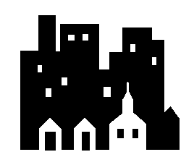 | city  (sitie) | stad
 | country  (kantrie) | land
 | England  (inklund) | Engeland
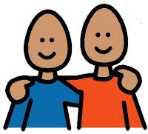 | friend  (frend) | vriend, vriendin
 | Mike is my best friend.  Jill is my friend. | Mike is mijn beste vriend.  Jill is mijn vriendin.
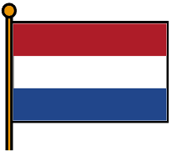 | Holland  (hollant) | Nederland
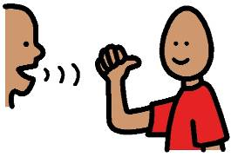 | language  (lengkwidzj) | taal
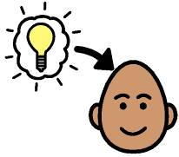 | learn  (lurn) | leren
 | I want to learn English. | Ik wil Engels leren.

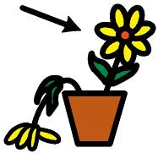 | live  (liv) | wonen, leven
 | Where do you live? | Waar woon je?
 | name  (neem) | naam
 | My name’s ..  What’s your name ? | Ik heet …  Hoe heet jij?
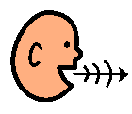 | speak  (spiek) | spreken,  praten
 | Do you speak English? | Spreek je Engels?
 | want  (want) | willen
 | I want to learn English. | Ik wil Engels leren.

 | …………… | ……………
 | …………… | ……………
 | …………… | ……………
 | …………… | ……………
 | …………… | ……………
 | …………… | ……………
 | …………… | ……………
 | …………… | ……………

 | baby  (beebie) | baby
 | boy  (boj) | jongen
 | brother  (bradur) | broer
 | I have two brothers. | Ik heb twee broers.
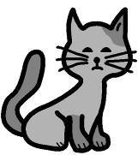 | cat  (ket) | poes
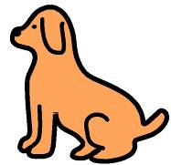 | dog  (dok) | hond
 | I like dogs. | Ik hou van honden.
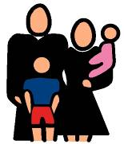 | family  (femulie) | familie
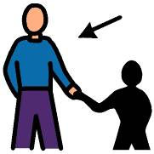 | father  (faddur) | vader

 | girl  (kurl) | meisje
 | grandfather  (grendfaddur) | opa
 | grandmother  (grendmaddur) | oma
 | have  (hev) | hebben
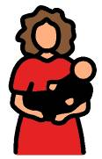 | mother  (moddur) | moeder
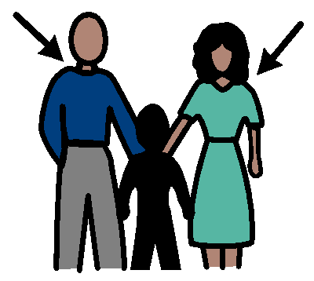 | parents  (perunts) | ouders
 | remember  (riemembur) | herinneren
 | I remember.  I don’t remember. | Ik weet het nog.  Ik weet het niet meer.

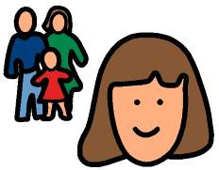 |  | sister  (sistur) |  | zus
 |  | year  (jier) |  | jaar
 |  | I am 40 years old. |  | Ik ben 40 jaar.

 | …………… | ……………
 | …………… | ……………
 | …………… | ……………
 | …………… | ……………
 | …………… | ……………
 | …………… | ……………
 | …………… | ……………
 | …………… | ……………

1 | one  (wan) | een
2 | two  (toe) | twee
3 | three  (srie) | drie
4 | four  (foor) | vier
5 | five  (faiv) | vijf
6 | six  (siks) | zes
7 | seven  (sevun) | zeven
8 | eight  (eet) | acht
9 | nine  (naajn) | negen
10 | ten  (ten) | tien
 | …………… | ……………

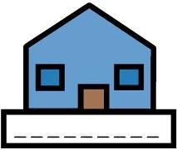 |  | address  (edrus) | adres
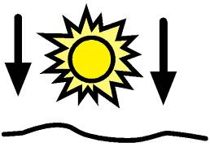 |  | afternoon  (afturnoen) | middag
 |  | Good afternoon! | Goedemiddag!
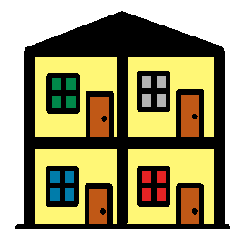 |  | apartment  (upartmunt) | appartement
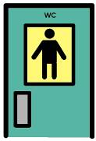 |  | bathroom  (bazroem) | WC  badkamer
 |  | Where’s the bathroom, please? | Waar is de wc?
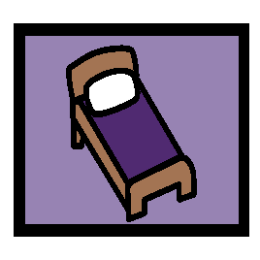 |  | bedroom  (betroem) | slaapkamer
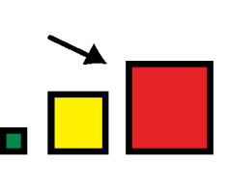 |  | big  (bik) | groot
 |  | This dog is very big. | Deze hond is erg groot.
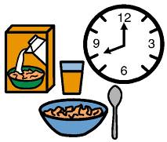 |  | breakfast  (brekfust) | ontbijt

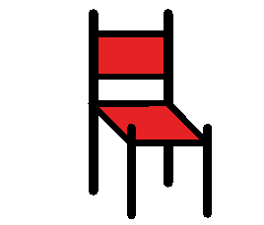 | chair  (tsjer) | stoel
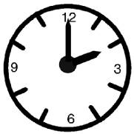 | clock  (klok) | klok
 | It’s five o’clock. | Het is vijf uur.
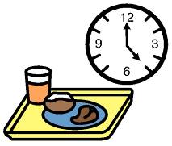 | dinner  (dinnur) | avondeten
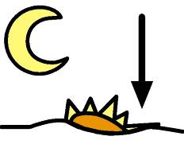 | evening  (ievning) | avond
 | Good evening! | Goedenavond!
 | flower  (flauwur) | bloem
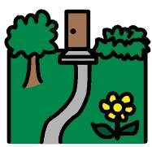 | garden  (kardun) | tuin
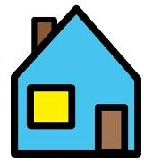 | house  (houz) | huis

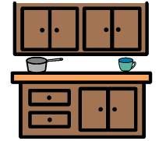 | kitchen  (kitsjun) | keuken
 | lamp  (lemp) | lamp
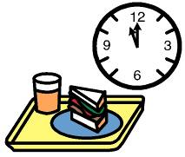 | lunch  (lansj) | lunch, middageten
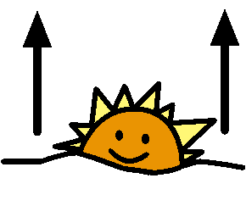 | morning  (morning) | ochtend
 | Good morning! | Goedemorgen!
 | night  (nait) | nacht
 | Good night! | Welterusten!
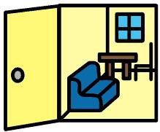 | room  (roem) | kamer
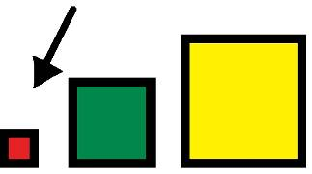 | small  (smol) | klein
 | This house is very small. | Dit huis is erg klein.

 | table  (teebul) | tafel
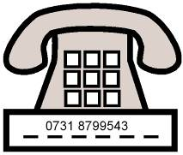 | telephone number  (telufoon nambur) | telefoonnummer

 | …………… | ……………
 | …………… | ……………
 | …………… | ……………
 | …………… | ……………
 | …………… | ……………
 | …………… | ……………
 | …………… | ……………
 | …………… | ……………

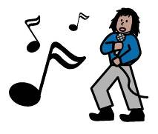 |  | band  (bend) | band
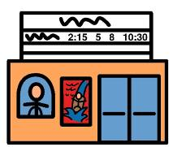 |  | cinema  (sinuma) | bioscoop
 |  | computer  (kompjoetur) | computer
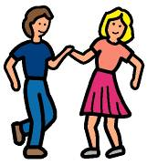 |  | dance  (dens) | dansen
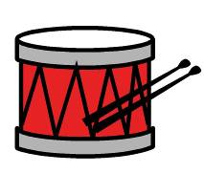 |  | drums  (drums) | drums
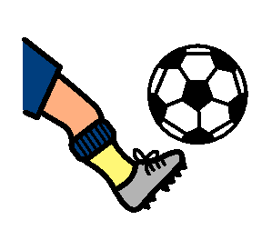 |  | football  (foetbol) | voetbal
 |  | free time  (frie taajm) | vrije tijd
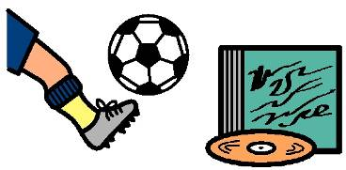 |  | hobby  (hobbie) | hobbie

 | I like …  (Aj laik) | Ik vind .. leuk.
 | I like dogs. | Ik vind honden leuk.
 | I don’t like …  (Aj don’t laik) | Ik vind … niet leuk.
 | I don’t like football. | Ik vind voetbal niet leuk.
 | I love …  (Aj lav) | ik hou van ….
 | I love dancing. | Ik hou van dansen.
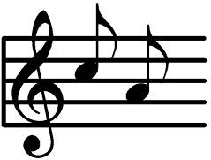 | music  (mjoezik) | muziek
 | I like listening to music. | Ik vind het leuk om naar muziek te luisteren.
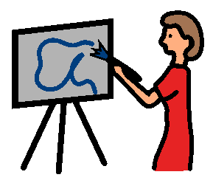 | paint  (peent) | schilderen
 | party  (partie) | feestje

 |  | sing  (sing) | zingen
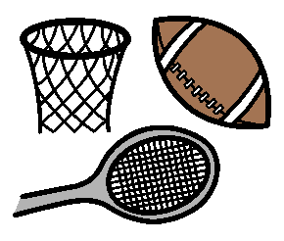 |  | sports  (sports) | sport
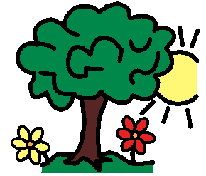 |  | summer  (sammur) | zomer
 |  | In the summer, I like swimming. | ’s Zomers vind ik zwemmen leuk.
 | swim  (swim) |  |  | zwemmen
 | television  (teluvizjun) |  |  | televisie
 | I want to watch television |  |  | Ik wil televisie kijken.
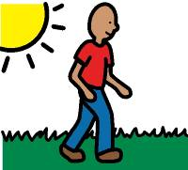 | walk  (wok) |  |  | wandelen
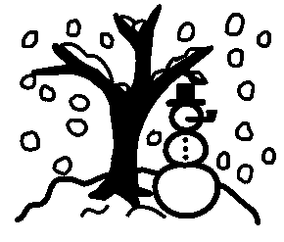 | winter  (wintur) |  |  | winter

 | …………… | ……………
 | …………… | ……………
 | …………… | ……………
 | …………… | ……………
 | …………… | ……………
 | …………… | ……………
 | …………… | ……………
 | …………… | ……………

 | beer  (bier) | bier
 | birthday  (burzdeej) | verjaardag
 | Happy Birthday! | Hartelijk gefeliciteerd!
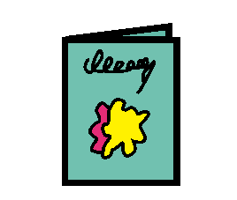 | birthday card  (burzdeej kard) | verjaardags-kaart
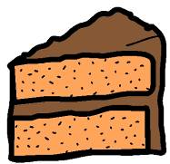 | cake  (keek) | taart
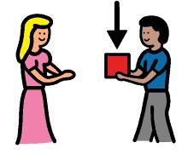 | get  (get) | krijgen
 | Mike gets a present. | Mike krijgt een cadeautje.
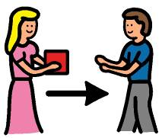 | give  (giv) | geven
 | Jill gives him a present. | Jill geeft hem een cadeautje.
 | hot dog  (hotdog) | hot dog

 | ice cream  (ajskriem) | ijs
 | party  (partie) | feestje
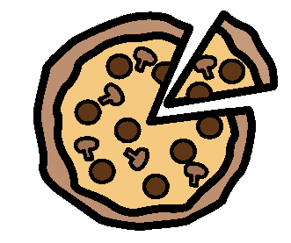 | pizza  (pietza) | pizza
 | present  (presunt) | cadeau
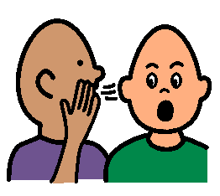 | secret  (siekrut) | geheim
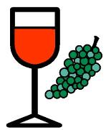 | wine  (wajn) | wijn
 | write  (raajt) | schrijven

 | …………… | ……………
 | …………… | ……………
 | …………… | ……………
 | …………… | ……………
 | …………… | ……………
 | …………… | ……………
 | …………… | ……………

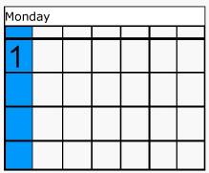 | Monday  (mondeej) | maandag
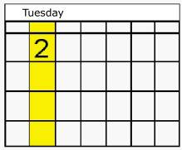 | Tuesday  (tjoesdeej) | dinsdag
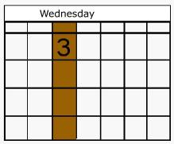 | Wednesday  (wensdeej) | woensdag
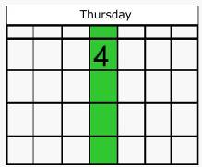 | Thursday  (tursdeej) | donderdag
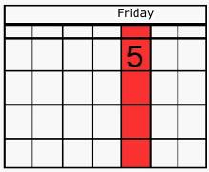 | Friday  (fraajdeej) | vrijdag
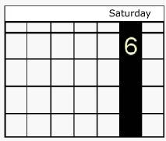 | Saturday  (seturdeej) | zaterdag
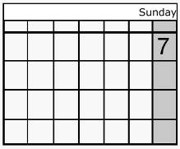 | Sunday  (sandeej) | zondag
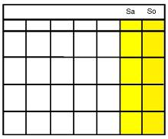 | weekend  (wiekent) | weekend

 | today  (toedeej) | vandaag
 | tomorrow  (toemoroow) | morgen
 | yesterday  (jestudeej) | gisteren
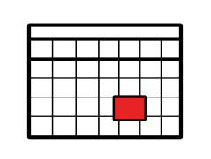 | day  (deej) | dag
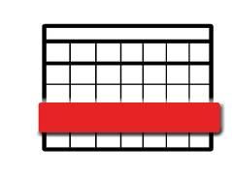 | week  (wiek) | week
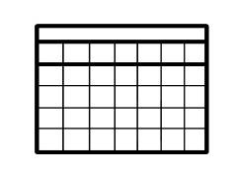 | month  (mans) | maand
 | year  (jier) | jaar

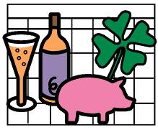 | January  (djenjoewurie) | januari
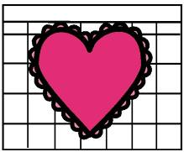 | February  (febroewurie) | februari
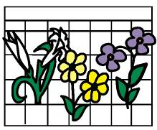 | March  (martsj) | maart
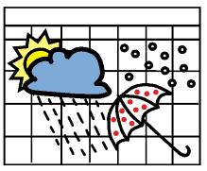 | April  (eepril) | april
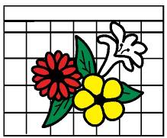 | May  (meej) | mei
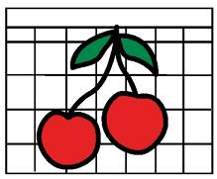 | June  (dzjoen) | juni
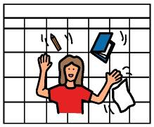 | July  (dzjoelaai) | juli
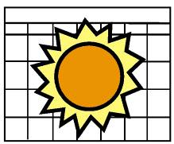 | August  (ogust) | augustus
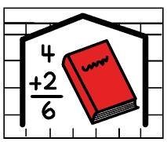 | September  (septembur) | september
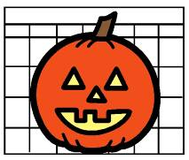 | October  (oktoobur) | oktober
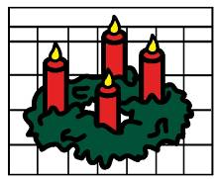 | November  (noovembur) | november
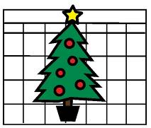 | December  (diesembur) | december
 | Christmas  (kristmus) | Kerstmis
 | Merry Christmas! | Vrolijk kerstmis!
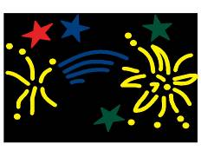 | New Year  (noe jier) | Nieuwjaar
 | Happy New Year! | Gelukkig nieuwjaar!
 | Birthday  (burzdeej) | Verjaardag
 | Happy Birthday! | Hartelijk gefeliciteerd!

 | …………… | ……………
 | …………… | ……………
 | …………… | ……………
 | …………… | ……………
 | …………… | ……………
 | …………… | ……………
 | …………… | ……………

 | angry  (engrie) | boos
 | I am angry. | Ik ben boos.
 | arm  (arm) | arm
 | bad  (bed) | slecht
 | I feel bad. | Ik voel me niet goed.
 | doctor  (doktur) | dokter
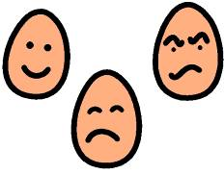 | feel  (fiel) | voelen
 | I feel sick. | Ik voel me ziek.
 | good  (koed) | goed
 | I feel good. | Ik voel me goed.
 | happy  (hepie) | gelukkig
 | I am happy. | Ik ben gelukkig.

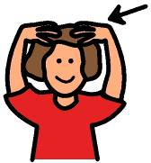 | head  (hed) | hoofd
 | headache  (hedek) | hoofdpijn
 | I have a headache. | Ik heb hoofdpijn.
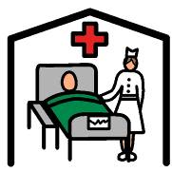 | hospital  (hospitul) | ziekenhuis
? | how  (hauw) | hoe
 | How are you? | Hoe gaat het met je?
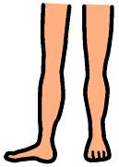 | leg  (lek) | been
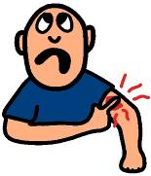 | pain  (peen) | pijn
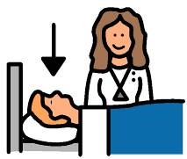 | patient  (peesjunt) | patient

 | sad  (sed) | verdrietig
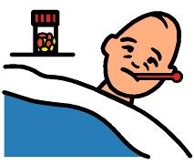 | sick  (sik) | ziek
 | I am sick. | Ik ben ziek.
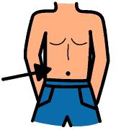 | stomach  (stomuk) | maag
 | I have a pain in my stomach. | Ik heb pijn in mijn maag.
 | tired  (taajurd) | moe
 | very  (verie) | erg
 | I am very tired | Ik ben erg moe
 | well  (wel) | goed

 | …………… | ……………
 | …………… | ……………
 | …………… | ……………
 | …………… | ……………
 | …………… | ……………
 | …………… | ……………
 | …………… | ……………
 | …………… | ……………

 | bag  (beg) | tas
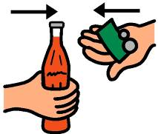 | buy  (baaj) | kopen
 | I want to buy new shoes. | Ik wil nieuwe schoenen kopen.
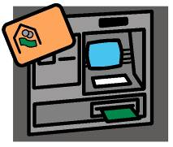 | cash point  (kesj pojnt) | geld automaat
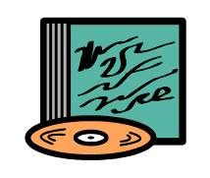 | CD  (siedie) | CD
 | cheap  (tsjiep) | goedkoop
 | This bag is very cheap. | Deze tas is heel goedkoop.
 | chemist  (kemist) | drogist
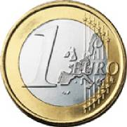 | Euro  (joeroo) | Euro

 | excuse me!  (ekskjoes mie) | pardon!
 | expensive  (ekspensiv) | duur
 | how much?  (houw matsj) | Hoeveel?
 | How much is this CD? | Hoeveel kost deze CD?
 | look for  (loek for) | zoeken
 | I’m looking for a present. | Ik zoek een cadeautje.
 | money  (monie) | geld
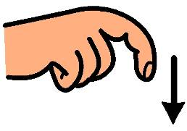 | need  (nied) | nodig hebben
 | I need a bag. | Ik heb een tas nodig.
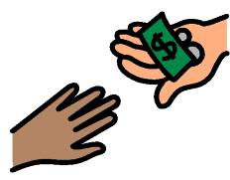 | pay  (peej) | betalen
 | please  (pliez) | alstublieft
 | Can you help me, please? | Kunt u me alstublieft even helpen?
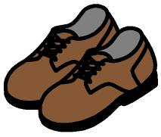 | shoes  (sjoez) | schoenen
 | shop  (sjop) | winkel, winkelen
 | I love shopping. | Ik hou van winkelen.
 | stamp  (stemp) | postzegel
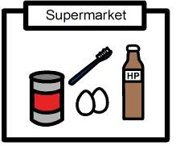 | supermarket  (soepermarkut) | supermarkt
 | sweater  (swetur) | trui
 | thank you!  (senk joe!) | dank u wel!
 | Thank you very much! | Hartelijk bedankt!

 | …………… | ……………
 | …………… | ……………
 | …………… | ……………
 | …………… | ……………
 | …………… | ……………
 | …………… | ……………
 | …………… | ……………

 | bad  (bed) | slecht
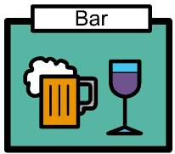 | bar  (bar) | café
 | beer  (bier) | bier
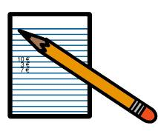 | bill  (bil) | rekening
 | Can we have the bill, please? | Kunnen we alstublieft de rekening krijgen?
 | bottle  (bottul) | fles
 | bread  (bred) | brood
 | cake  (keek) | taart

 | cheers!  (tsjiers!) | proost!
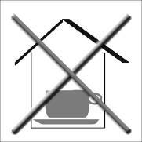 | closed  (kloozt) | gesloten
 | coffee  (koffie) | koffie
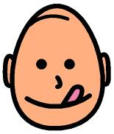 | delicious  (dielisjus) | heerlijk
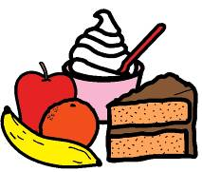 | dessert  (desurt) | toetje
 | drink  (drink) | drinken
 | What would you like to drink? | Wat wil je drinken?
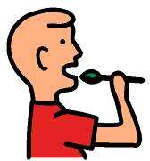 | eat  (iet) | eten
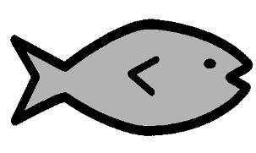 | fish  (fisj) | vis
 | glass  (glaz) | glas
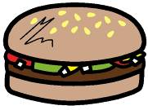 | hamburger  (hemburgur) | hamburger
 | ice cream  (aajs kriem) | ijsje
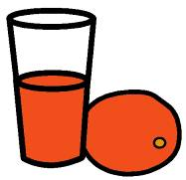 | juice  (djoes) | sap
 | orange juice | sinaasappelsap
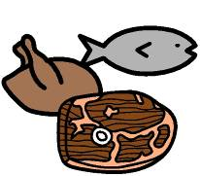 | main course  (meen koors) | hoofdgerecht
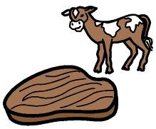 | meat  (miet) | vlees
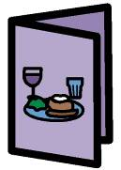 | menu  (menjoe) | menu
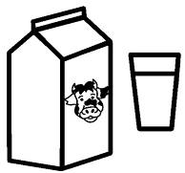 | milk  (milk) | melk

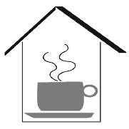 | open  (oopun) | open
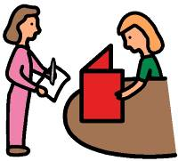 | order  (oordur) | bestellen
 | Are you ready to order? | Wilt u al bestellen?
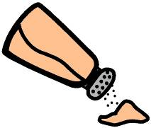 | pepper  (peppur) | peper
 | pizza  (pietza) | pizza
 | please  (pliez) | alstublieft
 | Can I have the menu, please? | Kan ik alstublieft het menu krijgen?
 | restaurant  (restorant) | restaurant
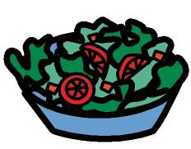 | salad  (selud) | sla, salade

 | salt  (solt) | zout
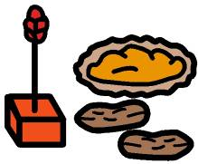 | starter  (startur) | voorafje
 | sugar  (sjoegur) | suiker
 | table  (teebul) | tafel
 | A table for two. | Een tafeltje voor twee personen.
 | tea  (tie) | thee
 | A nice cup of tea. | Een lekker kopje thee.
 | thank you!  (senk joe!) | dank u wel!
 | Thank you very much! | Hartelijk bedankt!
 | vegetables  (vedzjutubuls) | groente
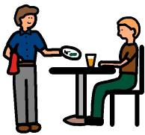 | waiter  (weetur) | ober
 | water  (wotur) | water
 | wine  (waajn) | wijn

 | …………… | ……………
 | …………… | ……………
 | …………… | ……………
 | …………… | ……………
 | …………… | ……………
 | …………… | ……………
 | …………… | ……………
 | …………… | ……………

 | airplane  (erpleen) | vliegtuig
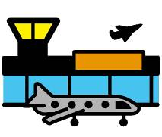 | airport  (erport) | vliegveld
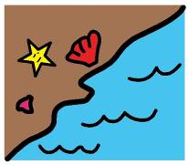 | beach  (bietsj) | strand
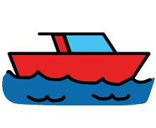 | boat  (boot) | boot
 | You can go there, by boat. | Je kunt er met de boot naar toe.
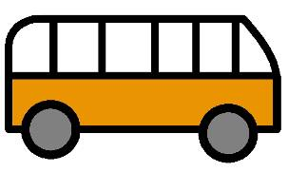 | bus  (bas) | bus
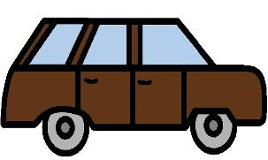 | car  (kar) | auto
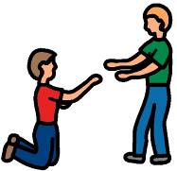 | help  (help) | helpen
 | Can you help me, please? | Kunt u me alstublieft even helpen?

 | holiday  (holiedeej) | vakantie
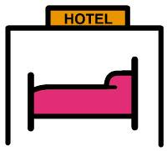 | hotel  (hootel) | hotel
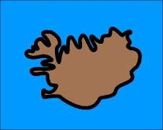 | island  (aajlund) | eiland
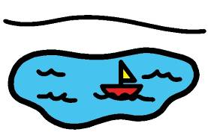 | lake  (leek) | meer
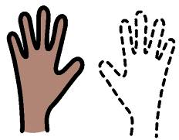 | left  (left) | links
 | lost  (lost) | kwijt
 | I’ve lost my passport. | Ik ben mijn paspoort kwijt.
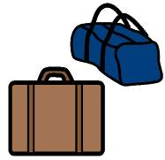 | luggage  (lakudzj) | baggage
 | Where is my luggage? | Waar is mijn bagage?

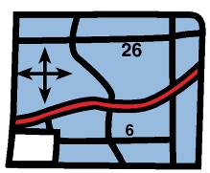 | map  (mep) | plattegrond
 | mountain  (mauntun) | berg
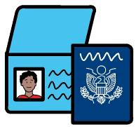 | passport  (pespoort) | paspoort
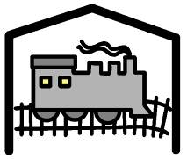 | railway station  (reelwee steesjun) | station
 | Where is the railway station? | Waar is het station?
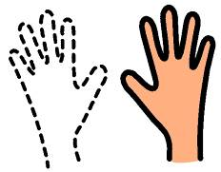 | right  (raajt) | rechts
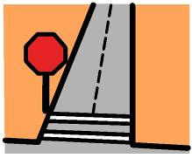 | street  (striet) | straat
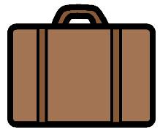 | suitcase  (soetkees) | koffer

 | tourist information  (toerist informeesjun) | VVV
 | Where is the Tourist Information? | Waar is het VVV kantoor?
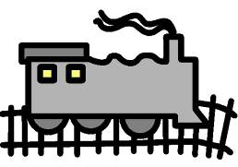 | train  (treen) | trein
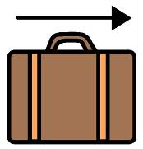 | travel  (trevul) | reizen
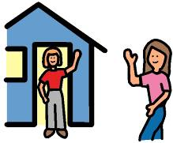 | visit  (vizit) | bezoek, bezoeken

 | …………… | ……………
 | …………… | ……………
 | …………… | ……………
 | …………… | ……………
 | …………… | ……………
 | …………… | ……………
 | …………… | ……………
 | …………… | ……………

A
 | Address |  |  | 3. My House
 | Afternoon | Good afternoon! |  | 3. My House
 | Airplane
 | Airport |  |  | 9. Going on Holiday
 | Angry | I am angry. |  | 6. How are you?
 | Apartment |  |  | 3. My House
 | April |  |  | 5. Happy Birthday!
 | Arm |  |  | 6. How are you?
 | August |  |  | 5. Happy Birthday!
B
 | Baby |  |  | 2. My Family
 | Bad | I feel bad. |  | 6. How are you?  8. Going to a Restaurant &
 | Bag |  |  | 7. Going shopping
 | Band |  |  | 4. My Hobbies
 | Bar |  |  | 8. Going to a Restaurant
 | Bathroom | Where’s the bathroom, please? |  | 3. My House
 | Beach |  |  | 9. Going on Holiday
 | Bedroom |  |  | 3. My House
 | Beer |  |  | 5. Happy Birthday! &
 |  |  |  | 8. Going to a Restaurant
 | Big | This dog is very big. |  | 3. My House
 | Bill | Can we have the bill, please? |  | 8. Going to a Restaurant
 | Birthday | Happy birthday! |  | 5. Happy Birthday!
 | Birthday card |  |  | 5. Happy Birthday!
 | Boat | You can go there, by boat. |  | 9. Going on Holiday
 | Bottle |  |  | 8. Going to a Restaurant
 | Boy |  |  | 2. My Family
 | Bread |  |  | 8. Going to a Restaurant
 | Breakfast |  |  | 3. My House
 | Brother | I have two brothers. |  | 2. My Family
 | Bus |  |  | 9. Going on Holiday
 | Buy | I want to buy new shoes. |  | 7. Going shopping
C
 | Cake |  |  | 5. Happy Birthday! &
 |  |  |  | 8. Going to a Restaurant
 | Car |  |  | 9. Going on Holiday
 | Cash point |  |  | 7. Going shopping
 | Cat |  |  | 2. My Family
 | CD |  |  | 7. Going shopping
 | Chair |  |  | 3. My House
 | Cheap | This bag is very cheap. |  | 7. Going shopping
 | Cheers! |  |  | 8. Going to a Restaurant
 | Chemist |  |  | 7. Going shopping
 | Christmas | Merry Christmas! |  | 5. Months
 | Cinema |  |  | 4. My Hobbies
 | City |  |  | 1. My Friends
 | Clock | It's five o'clock. |  | 3. My House
 | Closed |  |  | 8. Going to a Restaurant
 | Coffee |  |  | 8. Going to a Restaurant
 | Computer |  |  | 4. My Hobbies
 | Country |  |  | 1. My Friends
D
 | Dance |  |  | 4. My Hobbies
 | Day |  |  | 5. Happy Birthday!
 | December |  |  | 5. Months
 | Delicious |  |  | 8. Going to a Restaurant
 | Dessert |  |  | 8. Going to a Restaurant
 | Dinner |  |  | 3. My House
 | Doctor |  |  | 6. How are you?
 | Dog | I like dogs. |  | 2. My Family
 | Drink | What would you like to drink? |  | 8. Going to a Restaurant
 | Drums |  |  | 4. My Hobbies
E
 | Eat |  |  | 8. Going to a Restaurant
 | Eight |  |  | 2. Numbers
 | England |  |  | 1. My Friends
 | Euro |  |  | 7. Going shopping
 | Evening | Good evening! |  | 3. My House
 | Excuse me! |  |  | 7. Going shopping
 | Expensive |  |  | 7. Going shopping
F
 | Family |  |  | 2. My Family
 | Father |  |  | 2. My Family
 | February |  |  | 5. Months
 | Feel | I feel sick. |  | 6. How are you?
 | Fish |  |  | 8. Going to a Restaurant
 | Five |  |  | 2. Numbers
 | Flower |  |  | 3. My House
 | Football |  |  | 4. My Hobbies
 | Four |  |  | 2. Numbers
 | Free time |  |  | 4. My Hobbies
 | Friday |  |  | 5. Days
 | Friend | Mike is my best friend.  Jill is my friend. |  | 1. My Friends
G
 | Garden |  |  | 3. My House
 | Get | Mike gets a present. |  | 5. Happy Birthday!
 | Girl |  |  | 2. My Family
 | Give | Jill gives him a present. |  | 5. Happy Birthday!
 | Glass |  |  | 8. Going to a Restaurant
 | Good | I feel good. |  | 6. How are you?
 | Grandfather |  |  | 2. My Family
 | Grandmother |  |  | 2. My Family
H
 | Hamburger |  |  | 8. Going to a Restaurant
 | Happy | I am happy. |  | 6. How are you?
 | Have |  |  | 2. My Family
 | Head |  |  | 6. How are you?
 | Headache | I have a headache. |  | 6. How are you?
 | Help | Can you help me, please? |  | 9. Going on Holiday
 | Hobby |  |  | 4. My Hobbies
 | Holiday |  |  | 9. Going on Holiday
 | Holland |  |  | 1. My Friends
 | Hospital |  |  | 6. How are you?
 | Hot dog |  |  | 5. Happy Birthday!
 | Hotel |  |  | 9. Going on Holiday
 | House |  |  | 3. My House
 | How | How are you? |  | 6. How are you?
 | How much? | How much is this CD? |  | 7. Going Shopping
I
 | I don't like … | I don't like football. |  | 4. My Hobbies
 | I like … | I like dogs. |  | 4. My Hobbies
 | I love … | I love dancing. |  | 4. My Hobbies
 | Ice cream |  |  | 5. Happy Birthday! &
 |  |  |  | 8. Going to a Restaurant
 | Island |  |  | 9. Going on Holiday
J
 | January |  |  | 5. Months
 | Juice | orange juice |  | 8. Going to a Restaurant
 | July |  |  | 5. Months
 | June |  |  | 5. Happy Birthday!
K
 | Kitchen |  |  | 3. My House
L
 | Lake |  |  | 9. Going on Holiday
 | Lamp |  |  | 3. My House
 | Language |  |  | 1. My Friends
 | Learn | I want to learn English. |  | 1. My Friends
 | Left |  |  | 9. Going on Holiday
 | Leg |  |  | 6. How are you?
 | Live | Where do you live? |  | 1. My Friends
 | Look for | I am looking for a present. |  | 7. Going shopping
 | Lost | I've lost my passport. |  | 9. Going on Holiday
 | Luggage |  |  | 9. Going on Holiday
 | Lunch |  |  | 3. My House
M
 | Main course |  |  | 8. Going to a Restaurant
 | Map |  |  | 9. Going on Holiday
 | March |  |  | 5. Months
 | May |  |  | 5. Months
 | Meat |  |  | 8. Going to a Restaurant
 | Menu |  |  | 8. Going to a Restaurant
 | Milk |  |  | 8. Going to a Restaurant
 | Monday |  |  | 5. Days
 | Money |  |  | 7. Going shopping
 | Month |  |  | 5. Months
 | Morning | Good morning! |  | 3. My House
 | Mother |  |  | 2. My Family
 | Mountain |  |  | 9. Going on Holiday
 | Music | I like listening to music. |  | 4. My Hobbies
N
 | Name | My name's ..,.  What's your name? |  | 1. My Friends
 | Need | I need a bag. |  | 7. Going shopping
 | New Year | Happy New Year! |  | 5. Months
 | Night | Good night! |  | 3. My House
 | Nine |  |  | 2. Numbers
 | November |  |  | 5. Months
O
 | October |  |  | 5. Months
 | One |  |  | 2. Numbers
 | Open |  |  | 8. Going to a Restaurant
 | Order | Are you ready to order? |  | 8. Going to a Restaurant
P
 | Pain |  |  | 6. How are you?
 | Paint |  |  | 4. My Hobbies
 | Parents |  |  | 2. My Family
 | Party |  |  | 4. My Hobbies &
 |  |  |  | 5. Happy Birthday!
 | Passport |  |  | 9. Going on Holiday
 | Patient |  |  | 6. How are you?
 | Pay |  |  | 7. Going shopping
 | Pepper |  |  | 8. Going to a Restaurant
 | Pizza |  |  | 5. Happy Birthday! &
 |  |  |  | 8. Going to a Restaurant
 | Please | Can you help me, please? |  | 7. Going shopping &
 |  | Can I have the menu, please? |  | 8. Going to a Restaurant
 | Present |  |  | 5. Happy Birthday!
R
 | Railway station |  | Where is the railway station? | 9. Going on Holiday
 | Remember |  | I remember, I don't remember | 2. My Family
 | Restaurant |  |  | 8. Going to a Restaurant
 | Right |  |  | 9. Going on Holiday
 | Room |  |  | 3. My House
S
 | Sad |  |  | 6. How are you?
 | Salad |  |  | 8. Going to a Restaurant
 | Salt |  |  | 8. Going to a Restaurant
 | Saturday |  |  | 5. Days
 | Secret |  |  | 5. Happy Birthday!
 | September |  |  | 5. Months
 | Seven |  |  | 2. Numbers
 | Shoes |  |  | 7. Going shopping
 | Shop |  | I love shopping. | 7. Going shopping
 | Sick |  | I am sick. | 6. How are you?
 | Sing |  |  | 4. My Hobbies
 | Sister |  |  | 2. My Family
 | Six |  |  | 2. Numbers
 | Small |  | This house is very small. | 3. My House
 | Speak |  | Do you speak English? | 1. My Friends
 | Sports |  |  | 4. My Hobbies
 | Stamp |  |  | 7. Going shopping
 | Starter |  |  | 8. Going to a Restaurant
 | Stomach |  | I have a pain in my stomach. | 6. How are you?
 | Street |  |  | 9. Going on Holiday
 | Sugar |  |  | 8. Going to a Restaurant
 | Suitcase |  |  | 9. Going on Holiday
 | Summer |  | In the summer, I like swimming. | 4. My Hobbies
 | Sunday |  |  | 5. Days
 | Supermarket |  |  | 7. Going shopping
 | Sweater |  |  | 7. Going shopping
 | Swim |  |  | 4. My Hobbies
T
 | Table |  |  | 3. My House &
 |  |  | A table for two. | 8. Going to a Restaurant
 | Tea |  | A nice cup of tea. | 8. Going to a Restaurant
 | Telephone number |  |  | 3. My House
 | Television |  |  | 4. My Hobbies
 | Ten |  |  | 2. Numbers
 | Thank you! | Thank you very much! |  | 7. Going shopping &
 |  |  |  | 8. Going to a Restaurant
 | Three |  |  | 2. Numbers
 | Thursday |  |  | 5. Days
 | Tired |  |  | 6. How are you?
 | Today |  |  | 5. Days
 | Tomorrow |  |  | 5. Days
 | Tourist information |  |  | 9. Going on Holiday
 | Train |  |  | 9. Going on Holiday
 | Travel |  |  | 9. Going on Holiday
 | Tuesday |  |  | 5. Days
 | Two |  |  | 2. Numbers
V
 | Vegetables |  |  | 8. Going to a Restaurant
 | Very | I am very tired. |  | 6. How are you?
 | Visit |  |  | 9. Going on Holiday
W
 | Waiter |  |  | 8. Going to a Restaurant
 | Walk |  |  | 4. My Hobbies
 | Want | I want to learn English. |  | 1. My Friends
 | Water |  |  | 8. Going to a Restaurant
 | Wednesday |  |  | 5. Days
 | Weekend |  |  | 5. Days
 | Well |  |  | 6. How are you?
 | Wine |  |  | 5. Happy Birthday! &
 |  |  |  | 8. Going to a Restaurant
 | Winter |  |  | 4. My Hobbies
 | Write |  |  | 5. Happy Birthday!
Y
 | Year | I am 40 years old. |  | 2. My Family &
 |  |  |  | 5. Months
 | Yesterday |  |  | 5. Days

This dictionary is part of the English without Frontiers curriculum.
The English without Frontiers curriculum was developed as part of the BarrierFree Language Learning project and was made possible with financial support from the European Commission under the Socrates programme, Lingua Action 2
(http://eacea.cec.eu.int/index.htm ).

The opinions expressed in this work are the responsibility of the authors and do not necessarily reflect the official policy of the EC.

The pictures in the Dictionary are Picture Communication Symbols. The Picture Communication Symbols ©1981–2006 are owned by Mayer-Johnson LLC. All Rights Reserved Worldwide. Used with permission.

All rights reserved. No part of this publication may be translated, reproduced or transmitted, in any form or by any means, electronic (CD-ROM, Internet, etc.) or mechanical, including photocopying, recording or any information storage or retrieval system, without prior permission in writing from the publisher. Exceptions to this are the worksheets, flashcards, dictionary and computer activities; teachers are allowed – and even encouraged – to copy and adapt these to meet the needs of their learners.

International Sales and copyright:
© Pragma, the Netherlands
Slakkenstraat 58
6431 NJ Hoensbroek
the Netherlands
www.equalaccess.nl
info@equalaccess.nl
Website:
www.englishwithoutfrontiers.eu

